Packet

Ms. Slack
Tech 8
(revised 10/7/15)

Band Saw
Purpose: To cut irregular shapes and curves
Safety:
- Ask instructor for permission to use
- Wear safety glasses
- Remove jewelry, eliminate loose clothing, put up long hair
- The guide should always be from ⅛”-¼” above the work, use spacer to adjust height.
- Keep fingers away from the line of the blade
- Turn off machine to back out of a cut
- Do not attempt to cut a radius/curve tighter than the blade will allow
- Use relief cuts in tight areas
- Turn off machine and wait until the blade stops before you walk away from the machine
- Use a hand brush to clean off the bandsaw table
- Keep floor area clean to avoid accidents
________________________________________________________

Steps to set up machine:
- Adjust guide height using spacer, make sure guide is tightened
- Use push stick if necessary, so that your fingers are safely away from the blade

When in doubt or unsure about something, ASK your teacher!

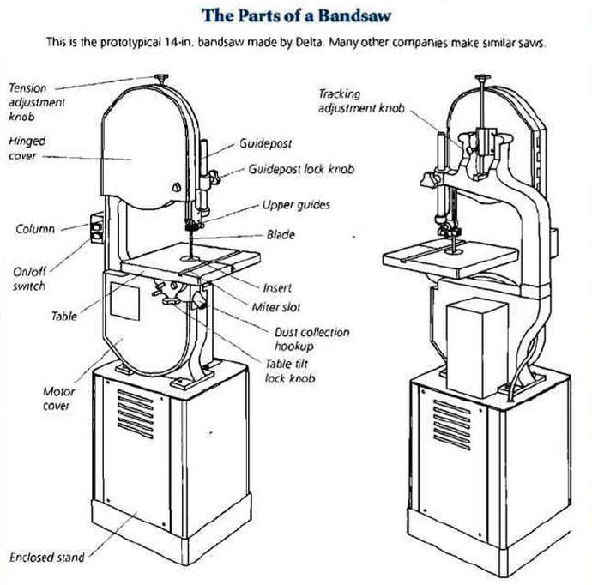
Drill Press

Purpose: To drill accurate holes in various materials
Safety:
- Ask instructor for permission to use
- Wear safety glasses
- Remove jewelry, eliminate loose clothing, put up long hair
- Lock in drill bit with chuck key, always remove it from the chuck
- Use scrap wood as a backing block below what you want to drill
- Always unlock table before lowering, lock when adjusted
- Securely clamp materials you will be drilling
- Turn off the machine and wait until the drill bit stops before you walk away from the machine
- Clean table with hand broom
________________________________________________________
Steps to set up machine:
- Lock drill bit in with the chuck key
- Clamp material to table if necessary

When in doubt or unsure about something, ASK your teacher!

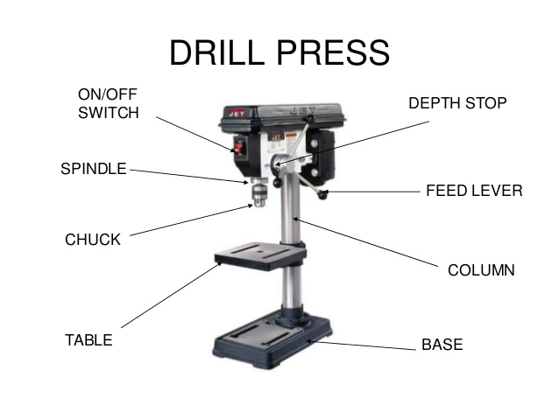
Word Bank:

On/Off Switch
Depth Stop
Spindle
Feed Lever
Chuck
Table
Base
Column
Scroll Saw

Purpose: To cut out intricate curved designs both inside and on the outer edge of a piece of work.
Safety:
- Ask instructor for permission to use
- Wear safety glasses
- Remove jewelry, eliminate loose clothing, put up long hair
- Adjust the guard by loosening the knob, the guard should sit on top of what you going to cut
- Adjust the variable speed knob
- Clamp a straight edge to the table if needed, double check that it’s adjusted to make an accurate cut
- Remove what you are going to cut from the guard before turning the saw on.
- Turn on the scroll saw and make your cut
- Turn off the machine and wait until the saw stops before you walk away from the machine
- Clean table with hand broom
________________________________________________________
Steps to set up machine:
- Adjust the guard
- Adjust the speed knob
- Clamp a straight edge in place if needed
- Turn on machine to cut your work

When in doubt or unsure about something, ASK your teacher!

